**Section 8 done: 40/40 A Real App: The Burger Builder (Basic Version)**\* It’s time to build a real React application so that we can see all these concepts come together so that we can get an idea how we actually plan such an application and how we build this tree of components and successfully use all the concepts we learned thus far, in an application.  
**Planning an App in React - Core Steps**  
* You can break this up into more granular steps but these are the 3 important steps I see.  
**1) Component Tree / Component Structure**  
=> You probably got a design by your designer or you basically created the app design and now it’s up to you to split this app into React components and it’s absolutely normal that the result that you may have at the end might look different than your initially planned component tree. But it’s super important to have an idea about what should go into its own component and what not.  
**2) Application State (Data)**  
=> You can also translate this with the data you plan on using and manipulating in your application. For example - and of course you will do this over the next lectures - in our Burger application we need to keep track about the ingredients that user added because that will determine what we need to render and also what the user needs to pay in the end.   
**3) Components vs Containers**  
=> Now once you know the component structure of your application and the state you’re going to use in it, you can plan components vs containers. Which components should be Stateless/Functional/Dumb/Container Components and which components have to be Stateful Component because they need to manage some state and distribute it down to the Stateless Components. And as you will see we might then even add more components then we initially planned because we see that we can split up even more or maybe that some split we did plan doesn’t make sense once we start implementing it. And that’s perfectly normal. But having a plan is of course very important.  
**Planning our App - Layout and Component Tree**  
* For this of course we need to define what our application actually is and what it should be able to do.  
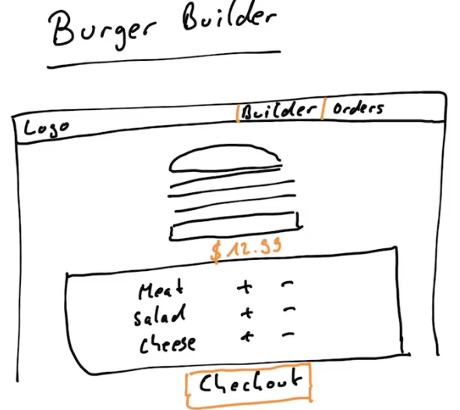  
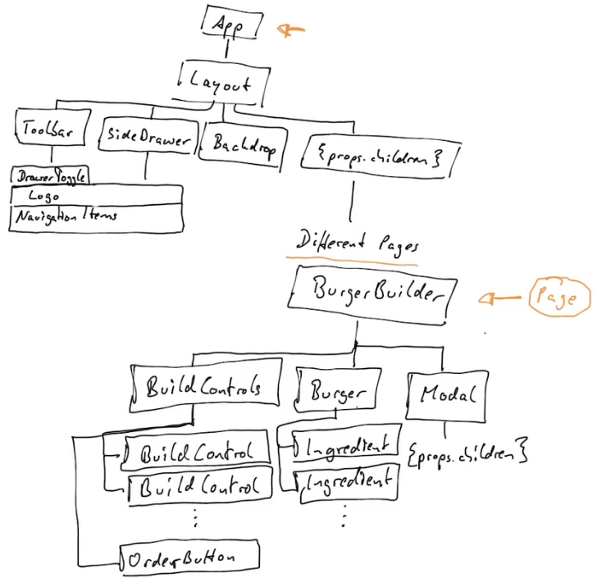  
=> the {props.children} in Layout - we want to have something which we can dynamically wrap, so whichever page you wanna display. Later in the app we’re going to add routing so that we can navigate to different pages so we might want to display the BurgerBuilder page or the Checkout page but all pages are going to share that layout. So we’re essentially going to use {props.children} here, allowing us to dynamically pass a component into depending on which page we wanna view.  
* The Modal probably should just be a wrapper component which in the end takes {props.children} to wrap itself around any content we wanna render in a modal so that we have a reusable modal, we could theoretically use for all kinds of stuff.  
=> Displaying our confirmations message, an erro message, or the order summary as we plan to do.  
* These are probably not all the components we’re going to add, but it is a good overview of our tree.  
=> We see that everything starts with 1 root component here - and then we split the tree up having a layout which could be a part of the root component and then having all the different branches.   
* Now here where we have the BurgerBuilder, this will be kind of like a page. It is a normal component but we probably will add more pages throughout this course when we start adding a page where we can see all past orders and stuff like that.  
**Planning the State**  
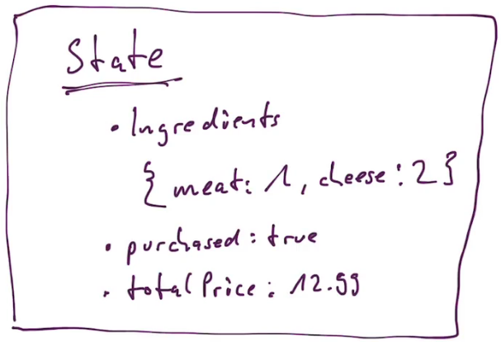

* Now where do we manage that state?   
=> You could say we should manage the state in the App component here at top. But I don’t agree with that.  
=> Instead, we should do it in the BurgerBuilder. Why? Because the state we listed is really just related to building a burger. If we later add a new checkout page or something like that, then we will basically have a page where we wanna see all orders of the user and we’re not interested in the ingredients of the burger the user currently builds.  
* Now the App.js component by default in a new project is a Stateful component created with the `class` keyword, we can of course always leave it to be one but we can also turn it into a dumb component if we wanted to.  
* Now if we’re thinking about PureComponents or shouldComponentUpdate(), we’ll implement this as we build the application and see if we can identify some places where we need to optimize our update cycle. But due to the simplicity of our state and the structure of our application here, it might also be the case that we never need to implement a PureComponent because we know that if the state or some props changes, it did really change, that we don’t have a button which might just set the state to something it was already at.  
**Setting up the Project**\* First we start the project with create-react-app.  
* Here we first want to enable CSS Modules so that we can make sure that the CSS classes we create in a CSS file can be scoped to a specific component in our application so that they are not applied globally when we would accidentally reuse the same CSS class.  
=> For that we need to `eject` the project.  
**npm run eject**  
=> In webpack.config files:  
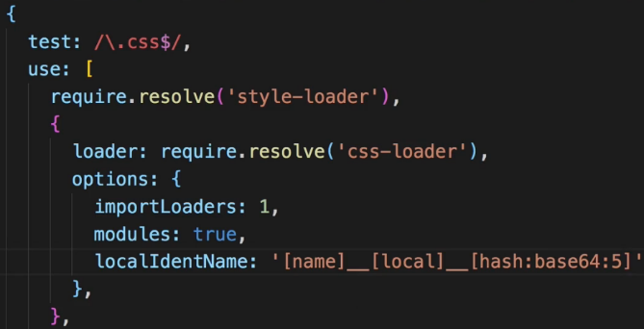 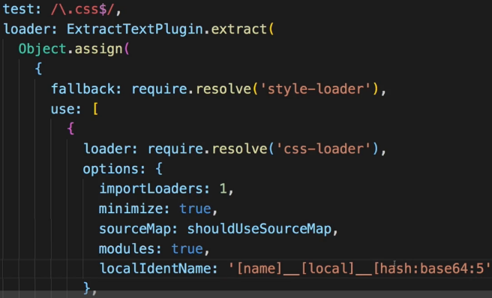  
* Now we have our project set up and we can get get started.  
* Let’s do some cleanup work - let’s remove that logo.svg and clean up the code in App.js, we can delete the App.css.  
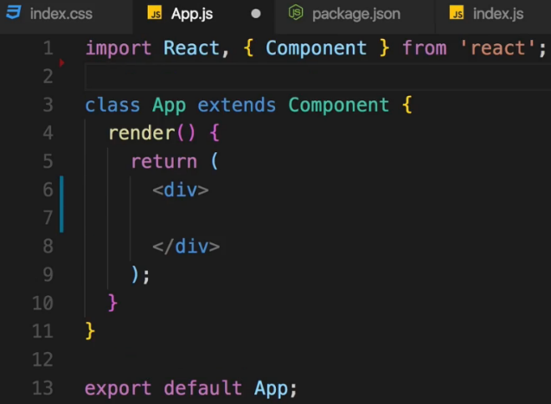  
* We can keep the index.css file and change the font there and still have it imported normally globally in the index.js file.  
=> Google Fonts > Open Sans > Customize > regular 400, bold 700 > Embed > copy the CDN link to the `public` folder and to the index.html file, and there add it right above the title. We’ll also adjust the title.  
  
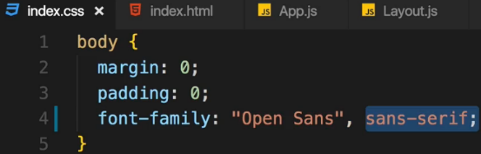  
=> Have Open Sans as our main font and have Sans Serif as a backup font.  
* With that the setup of the project is pretty much finished. We can now start writing our React application and implement that Component Tree we designed.  
**Creating a Layout Component**  
* I first of all will create that Layout component which will kind of be a wrapper, implementing the Toolbar and the BurgerBuilder in.  
* And later once we add routing and more pages to our application, we’ll take advantage of this Layout where the Toolbar will always be there but where we will then switch the page which is rendered in the content area of the Layout so to say.  
* Now we could simply turn the App.js file into a Layout because it basically is the root component of our application and that would be a perfectly fine approach. I will still create a separate component for that though, to have a component entirely focusing on the layout.  
* It is a typically project setup you use in React - having a `components` and `containers` folder.  
* Other folders you often see are `assets` - we will use this later once we add a logo.  
* And you might also have a folder for the Redux Store and so on - we will add it once we got that.  
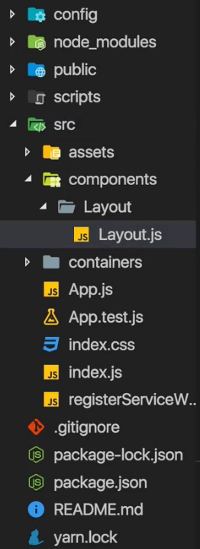  
* We will later replace the placeholder div with the 3 components.  
* In the <main> there I want to output the component we wrap with this Layout.  
* Now this allows us to simply use this Layout component as a wrapper around the core content component we wanna render to the screen.  
* We use HOC for having adjacent elements - NEW in React 16+ is the **FRAGMENTS <> </>**\* In this video we use our HOC we learned about.  
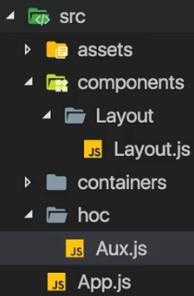  
* In Aux.js:  
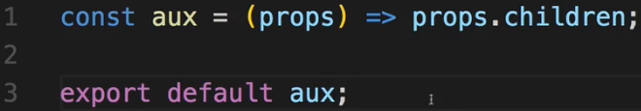  
* In Layout.js:  
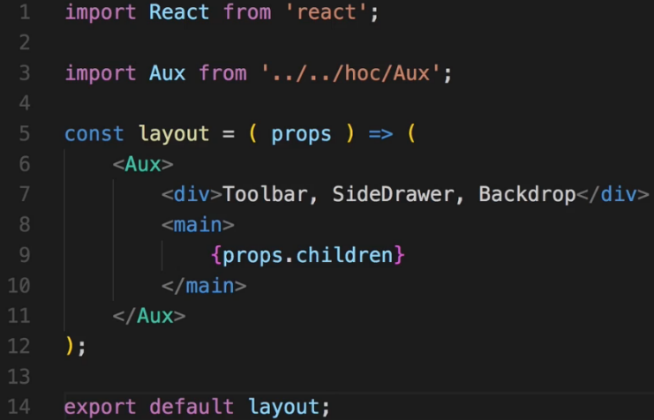  
* Now granted you could also go to the index.js file, import Layout here and simply ReactDOM.render() the Layout function as the root component. That’s basically the same solution as making the App.js file the root component. That wouldn’t be wrong. It’s just my personal decision to have this root component in case I should ever decide to restructure the app, add some state to my root component, maybe conditionally render different layouts or do anything like that.  
* In App.js:  
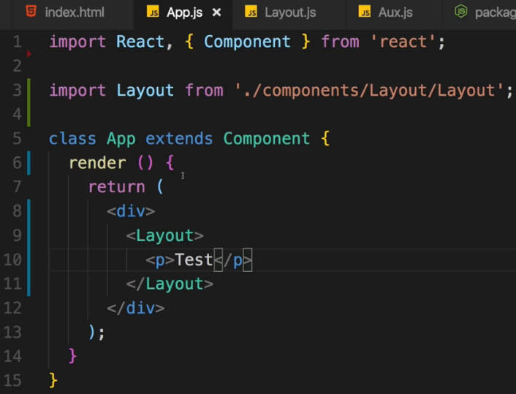  
* The Layout shouldn’t be a self-closing component because the idea behind the whole Layout is that I can wrap another component with it.  
* Later we will wrap a real component - the page we actually want to display - with it.  
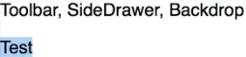  
* Now we got the roof of our application finished for now.  
**Starting Implementation of The Burger Builder Container**\* Now this will probably grow as we build this application. For example we might also return a modal here conditionally if it’s about the time to show it. But for now we want to render 2 different things.  
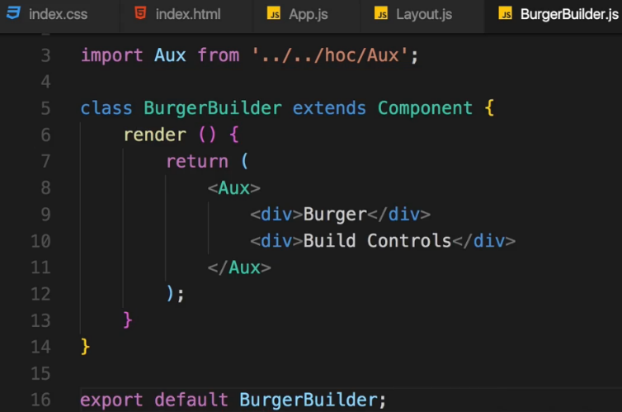  
* In App.js:  
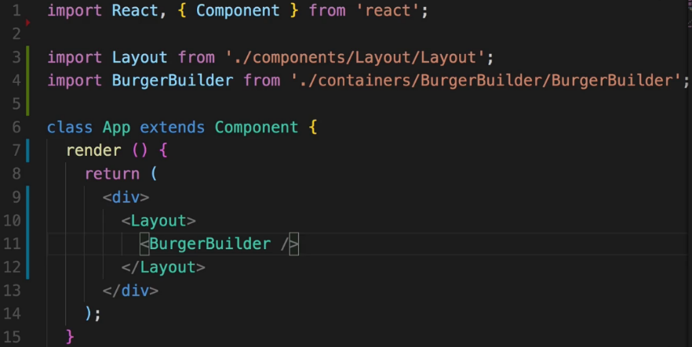  
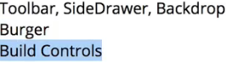  
* Now let’s add a bit of styling like a margin to at least separate them. And we will do this in the Layout.js component because it’s there where we have the area for the toolbar and the area for the main part.  
* In Layout.css: In Layout.js  
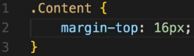 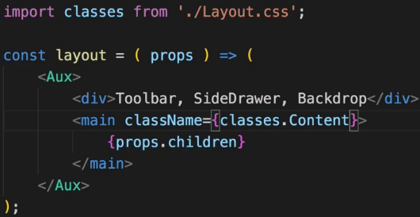  
**Adding a Dynamic Ingredient Component**\* You can download the BurgerIngredient.css file - using CSS only.  
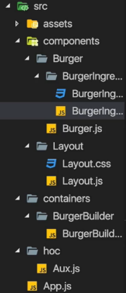

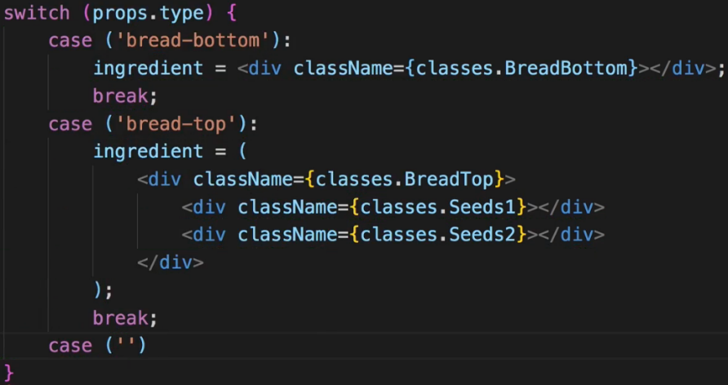  
=> We use case for each of the css classes we created in BurgerIngredient.css.  
* There are of course alternatives to this switch statement.  
* We set default: ingredient = null;  
* After that switch statement we can safely return that ingredient here. It’s either null or one of our many DIVs.  
* We can add PropType validation to it because we wanna make sure that we do receive a type property.  
**Adding Prop Type Validation**  
**npm install --save prop-types**  
  
=> You can use PropTypes only in Stateful components.  
=> You could add it to the containers folder but we still don’t plan on managing any state here or passing down any state to any other component, so for me it still stays a dumb/Stateless component, a normal Stateless component. That doesn’t change just because I create it with the `class` keyword. And that is generally important thing to understand - you don’t decide if something is a container or not with the `class` keyword. You can create all your components as a class if you want, it’s just a good practice to use the Functional form as often as possible but it’s not a must.  
=> Changing BurgerIngredient to a class.  
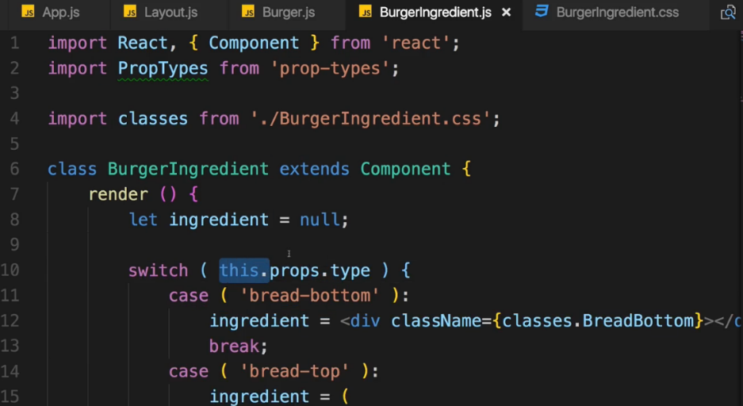  
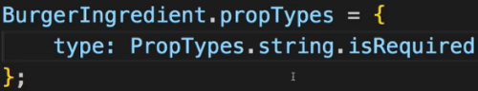  
=> So if we ever try to use the Ingredient component without passing a type, we will get an error.  
**Starting the Burger Component**  
* We will re-visit this component to enhance it and conditionally render something else later.  
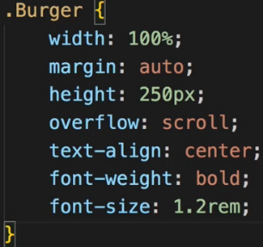  
* So this is the layout I wanna use, it’s the mobile layout though.  
* I now want to create a media query here to adjust it for larger screens.  
* The min-height: 700px is important because the Burger of course is built vertically.  
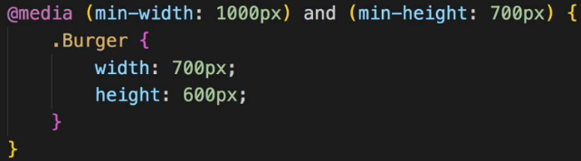  
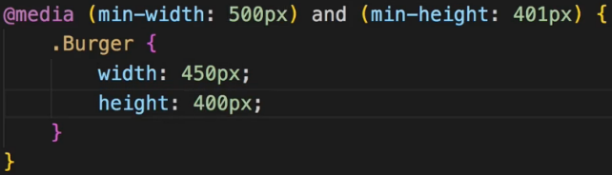  
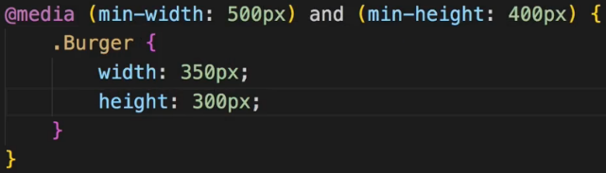  
* To also handle devices that are not that wide but pretty tall = in portrait mode.  
* There the class is always .Burger, the media query doesn’t matter for that.  
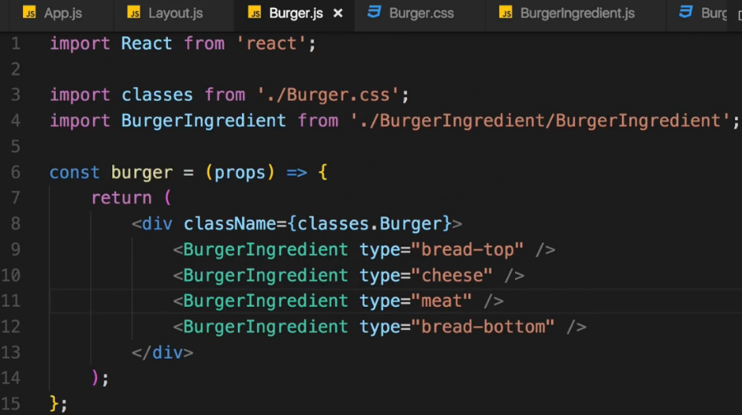  
* Now let’s simply render this burger.  
* In BurgerBuilder.js:  
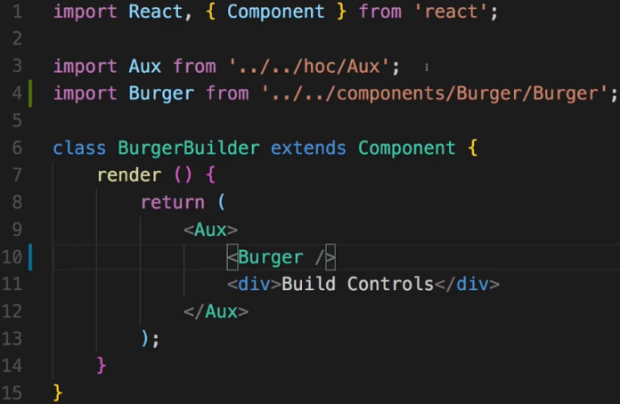

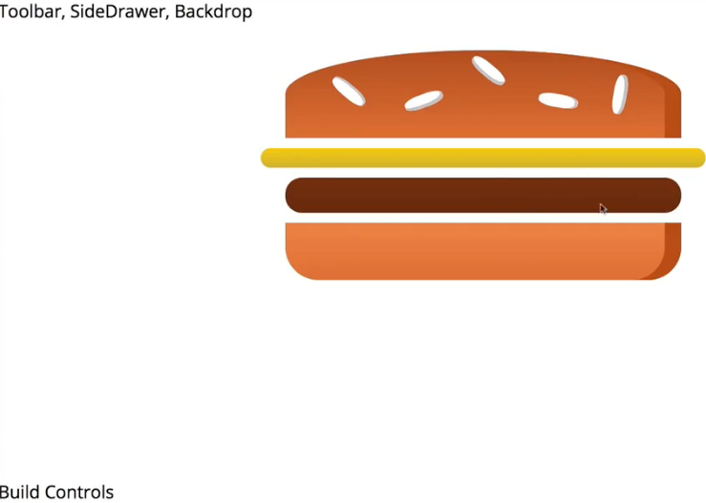  
* Right now everything about the Burger is now hard-coded. We’re not able to change this Burger dynamically and we’re not even rendering this dynamically. So let’s start by managing the ingredients via state and rendering the Burger dynamically.  
**Outputting Burger Ingredients Dynamically**  
* To create a state you can use either of these:  
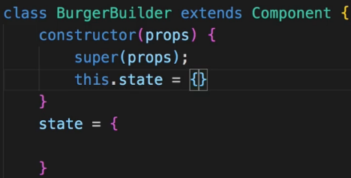  
* I’ll use this a bit more modern - because it’s shorter.  
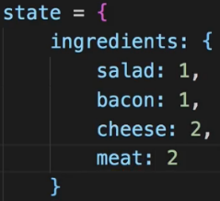  
* In BurgerBuilder.js:  
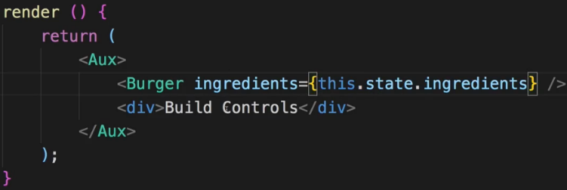  
* It’s an object, it’s not an array. So we can’t use .map() on that, we can’t just loop through that.  
=> Instead, we have to transform this object into an array and to be precise - we have to convert this object into an array of the values of the ingredients.   
=> Using **Object.keys()**  
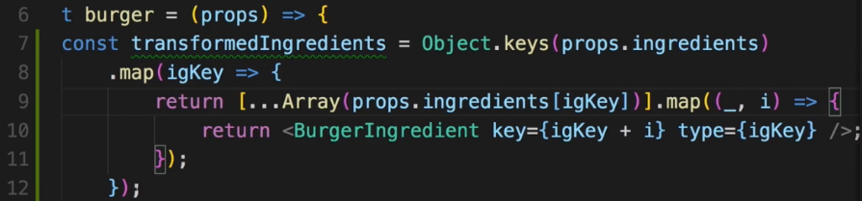  
=> It’s just a way of transforming an object of key-value pairs into an array of BurgerIngredients where the value of that object is important for me to decide how many ingredients I need and the key is important for which type of ingredient I need.  
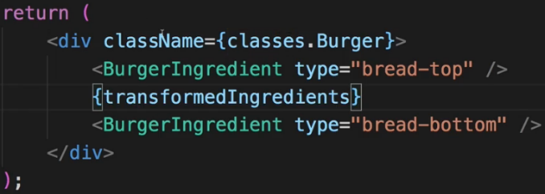  
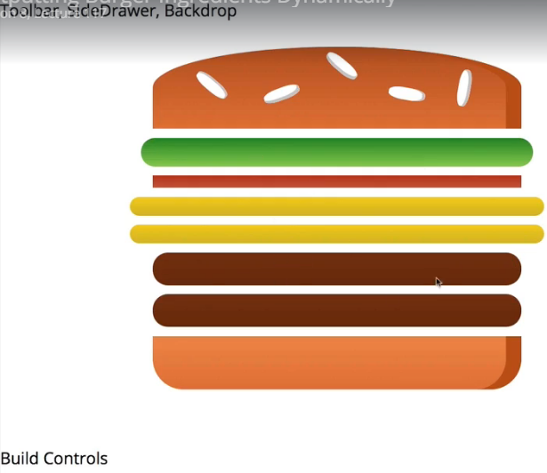  
* Now we have a generic map method of outputting ingredients.  
**Calculating the Ingredient Sum Dynamically**  
* What happens if we have a burger which starts with all ingredients set to 0 though?  
  
=> Would be nice to add something like a message in this case.  
* No to show something if we have no ingredients, we have to find out if we have no ingredients. The transformedIngredients is going to be an array of empty arrays in the end. But that is something that is kind of hard to check for us.  
=> We can reduce the transformedIngredients array.  
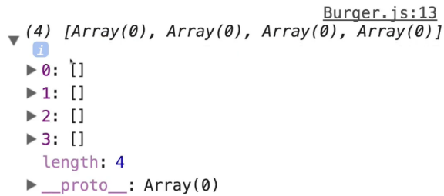  
=> This is what the transformedIngredients looks like now. We can simply flatten this array. And create 1 array only which contains all these values.  
=> We can do that by adding reduce to our transformedIngredients logic here.  
=> **.reduce()** is a built-in array function which allows us to transform an array into something else.  
* It takes a function as input and this function receives 2 arguments - passed in automatically by JavaScsript - the previous value (arr) and the current value (el). The .reduce() method does not only accept this callback here which is executed on every element in this array we return here - it also accepts an initial value, let’s say an empty array, so the initial value of the reduced value. And of course we wanna adjust this reduced value by returning something. And it will then loop through all the elements and simply add them to the initial value step by step. So here we want to return the updated value starting with the initial one is then stored in this first argument which we receive in each loop here. So this `arr` argument is the always updated root array which I want to return in the end. So I will simply concat something to that - .concat(el) - this will simply take the given element for which we’re looping and add it to this array.   
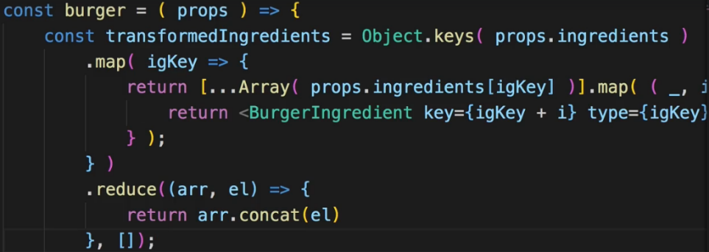  
=> Now we get an empty array.  
  
=> And if we introduce something like 2 cheese pieces, we get an array with 2 objects:  
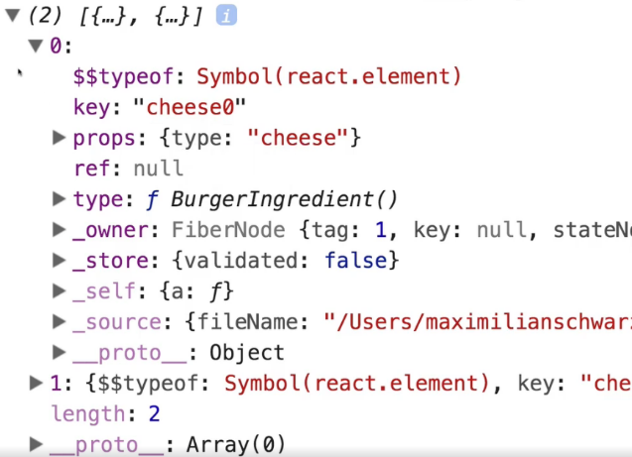  
=> They look strange because they are JSX elements handled by React.  
* Let’s use `let` for the transformedIngredients and do:  
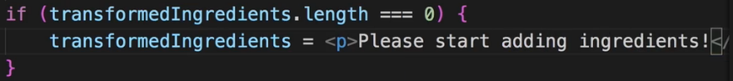  
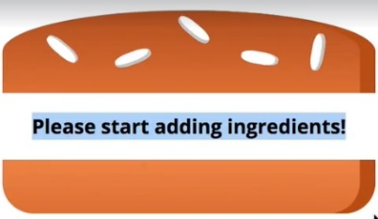  
**Adding the Build Control Component**  
* Adding BuildControls to the Burger folder.  
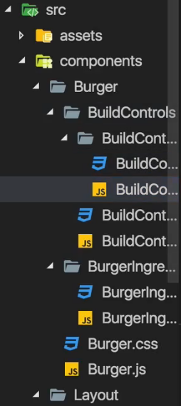 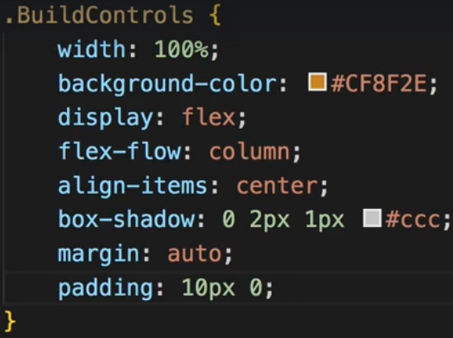  
* In my opinion it makes sense to also outsource these build controls because it’s not just 1 button, it’s a label and then 2 buttons and it’s basically a reusable UI element so putting it into its own component makes a lot of sense.  
* Adding BuildControl inside BuildControls.  
* In BuildControls and BuildControl we use a DIV for styling.  
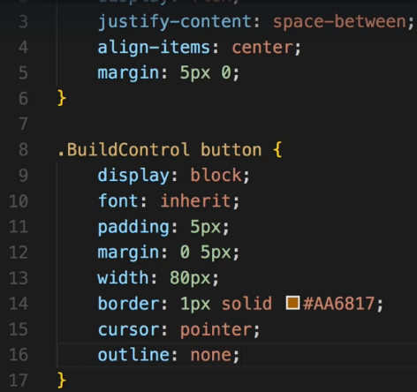  
=> All the other styles are in an attached file you can copy them.  
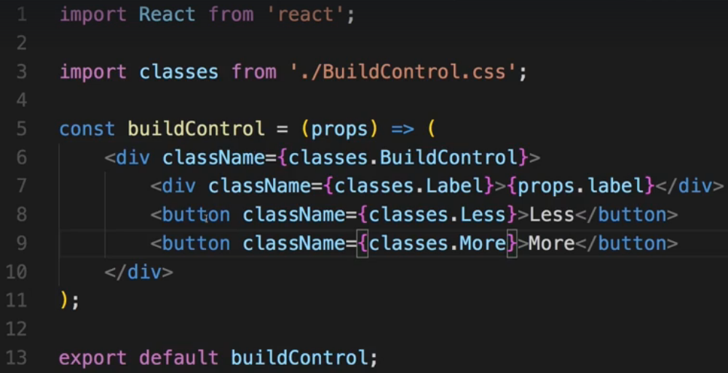  
=> Now a single BuildControl is styled and ready.  
**Outputting Multiple Build Controls**  
* I will create a constant which I won’t export, named controls.  
* And this is optional, you could just hard-code all the controls but I want to have an array through which I can loop to conveniently build all these BuildControls and render them.  
* In BuildControls.js:  
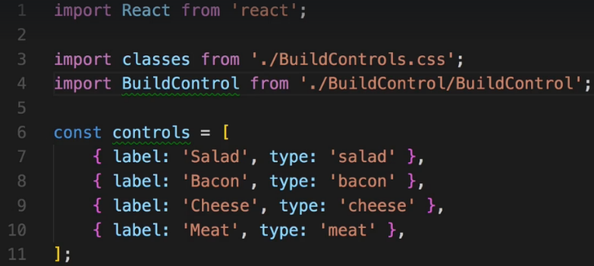  
* Now let’s create a loop with {} to inline it here because it’s really short.  
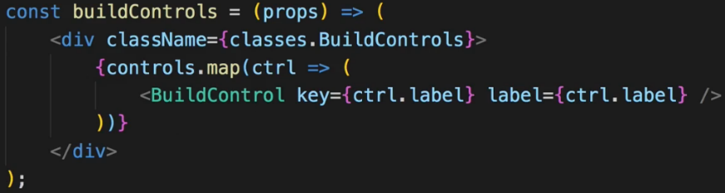  
* Let’s now import it to the BurgerBuilder.js and use it there.  
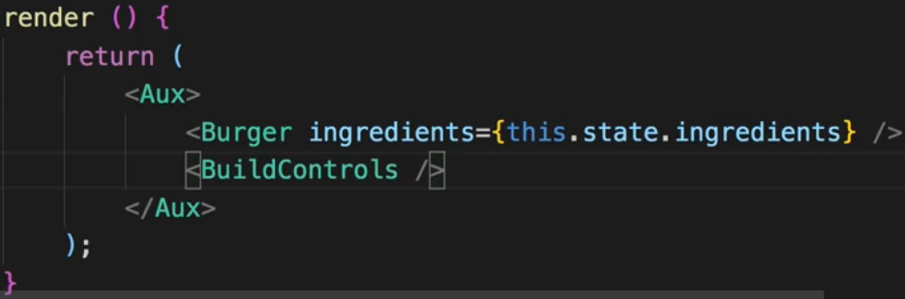  
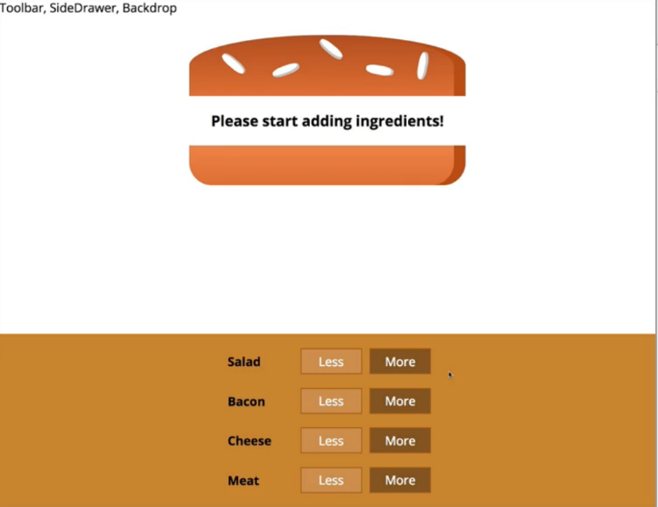  
* The buttons don’t do anything let but we’re very close.  
**Connecting State to Build Controls**  
* To update the ingredients in the state, I will create a new constant updatedIngredients because as you learned, state should be updated in an immutable way.   
* Let’s also keep track of total price in the state.  
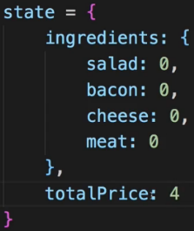  
=> For that we need to have a mapping of which ingredient costs what, for that I will create a new constant outside of the class.  
=> You typically name constants you wanna use as **GLOBAL CONSTANTS** in **ALL CAPITAL**.  
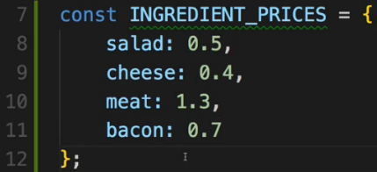  
* You could do these calculations in less lines.  
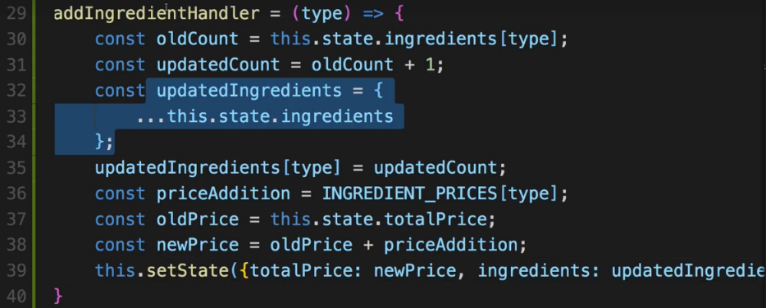

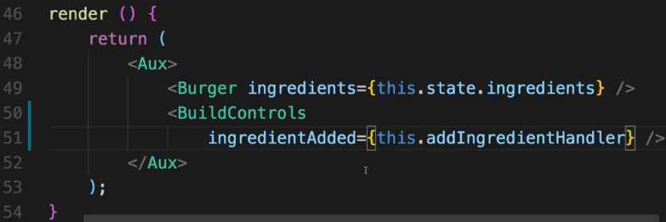  
* Now inside BuildControls.  
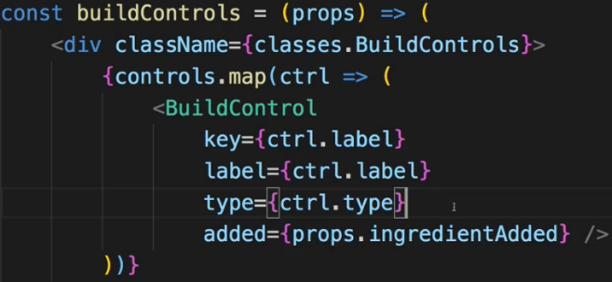 => 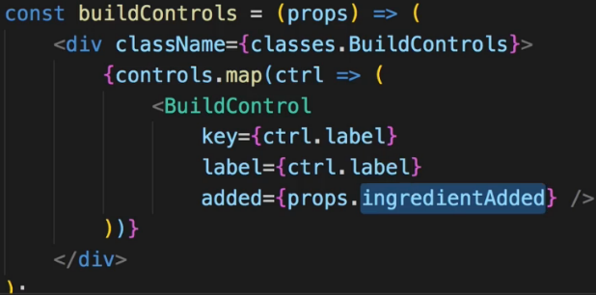  
=> Now with that in here I pass it on to the individual BuildControl so that it can call that. However, I also need to keep track of which type this BuildControl is of so which type this BuildControl has. And we have all the types in the constant above and use it to create all these controls so I can also pass on the types.   
=> Now I could do that but essentially that’s an unnecessary extra loop. I would now implement a click listener in the BuildControl to just return everything back up.  
=> So I can just omit this and instead set up ES6 function here, execute props.ingredientAdded() so the function reference we’re receiving in BuildControls and there simply pass back ctrl.type. Remember I have access to ctrl.type here because we’re inside that loop where we’re looping through all the controls and each control has a type.  
=> Now I’m executing ingredientAdded() which in the end will lead to nothing else than addIngredientHandler being executed and there I expect to get type as an argument.  
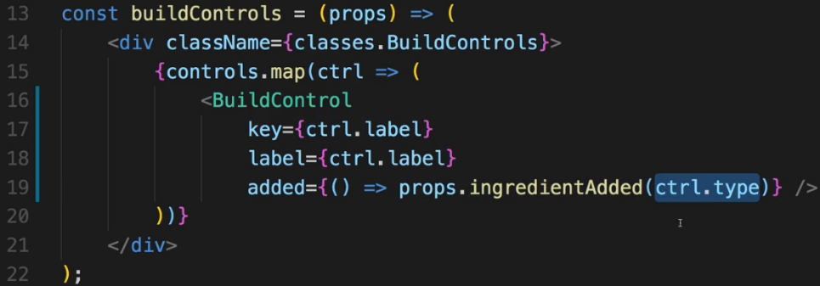  
=> Now of course for this to work, this `added` property which we’re passing to a single BuildControl, needs to be connected to the More button.  
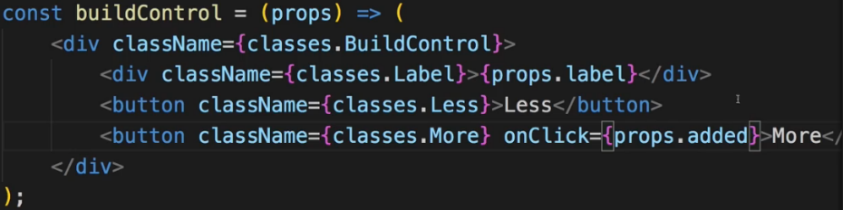  
* Now adding ingredients works perfectly even visually.  
**Removing Ingredients Safely**  
* It’s actually very similar to adding.  
  
  
  
* In BurgerBuilder.js:  
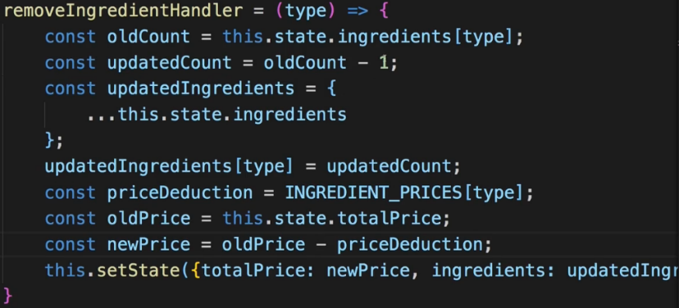  
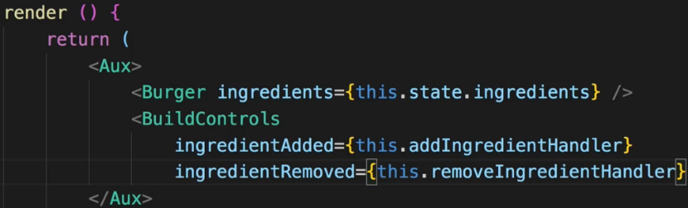  
* In BuildControls.js:  
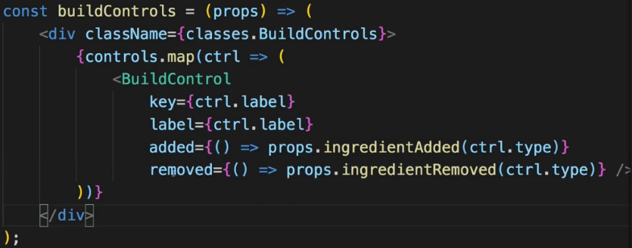  
* In BuildControl.js:  
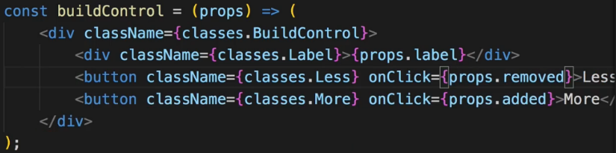  
* Now this removing works.  
* We have a problem when we start removing ingredients that we don’t have though. So the state becomes negative and that throws an erro because we can’t create an array from a negative number.  
=> So in the removeIngredientHandler we should check if we do have the ingredient.   
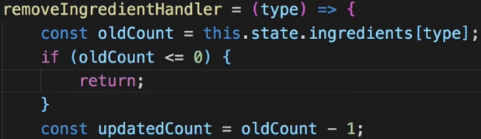  
* Of course it would be even better if the button would be disabled then.  
=> There I want to pass some information about which button should be enabled and which button should be disabled, to my BuildControls.  
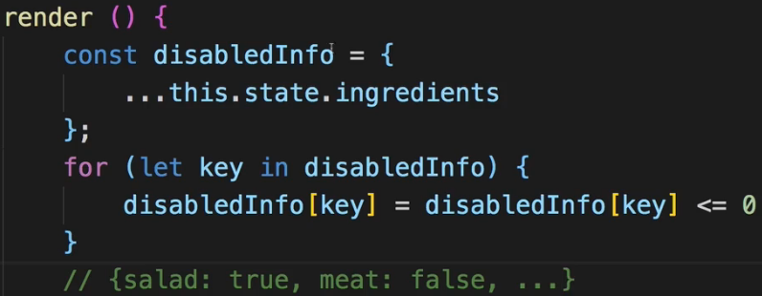  
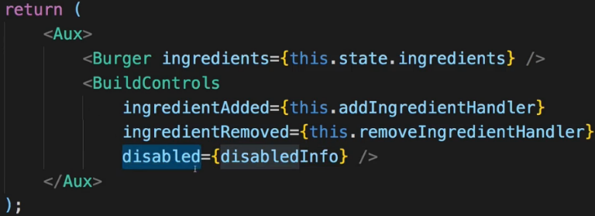  
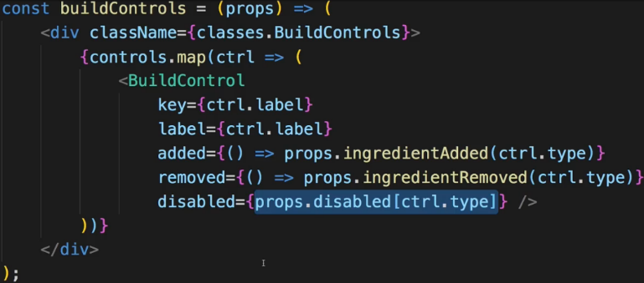  
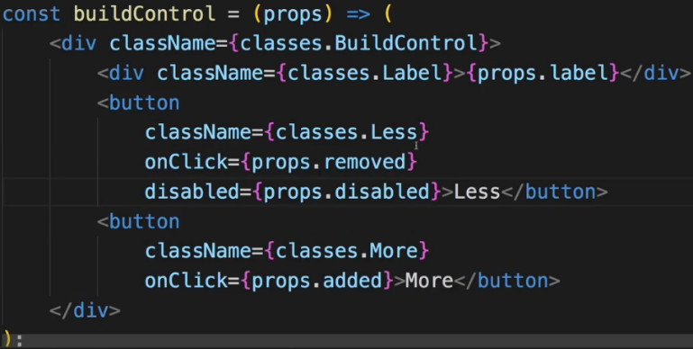  
* The styling is set up to style the button differently when disabled.  
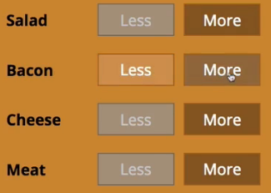  
**Displaying and Updating the Burger Price**  
* Now if I add a lot of ingredients, it is scrollable because we configured it to be scrollable. So the price should probably be displayed above the build controls let’s say.  
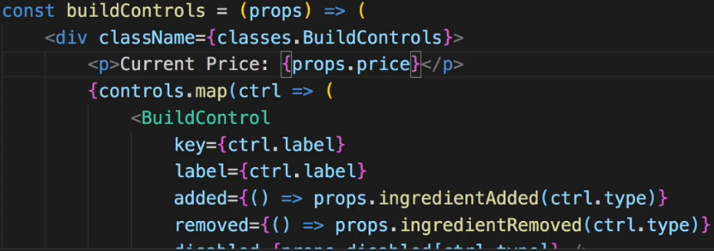  
* In BurgerBuilder.js:  
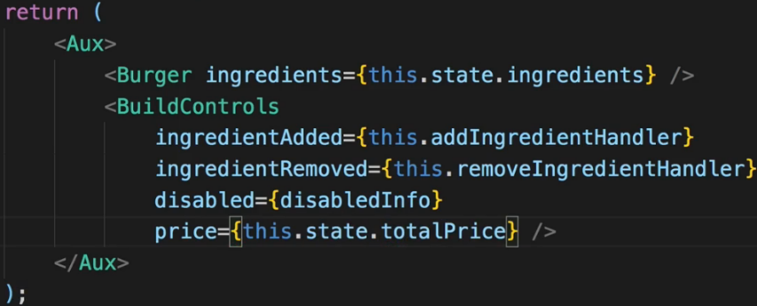

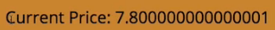  
=> Here we have a bug with decimal numbers in JavaScript so we should fix this.  
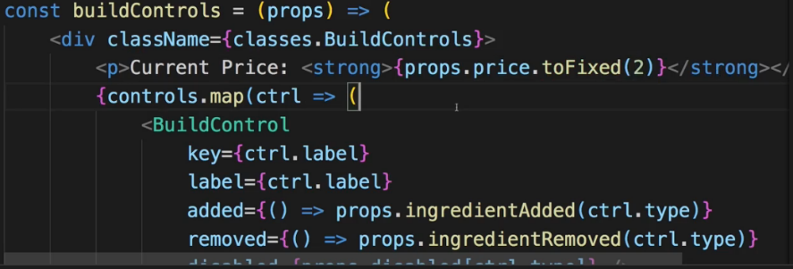  
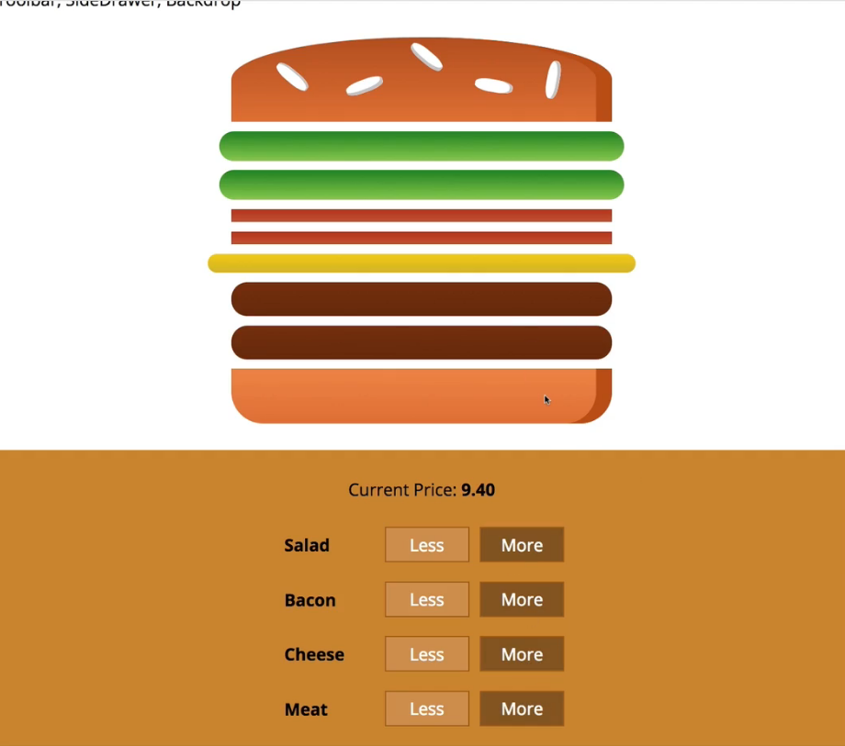  
**Adding the Order Button**  
* Now let’s create the modal which allows us to display order summary. This modal should be shown once we click the checkout button which we also need to add, below our build controls.  
* Copy the styles into BuildControls.css to style the .OrderButton - hover, active, disabled and a little animation which will simply animate the button once it becomes active.  
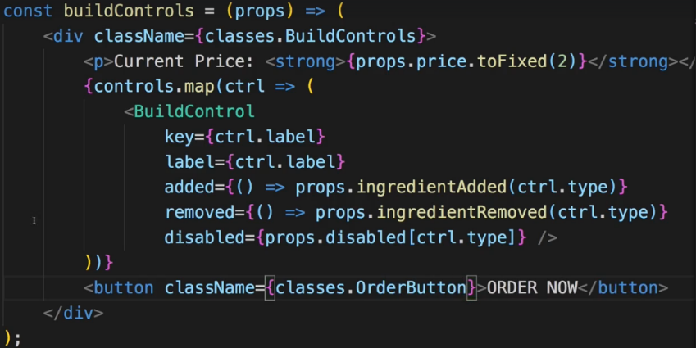 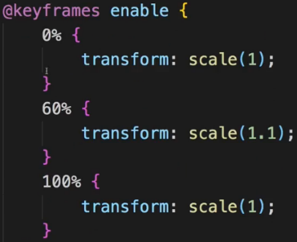  
=> If at least 1 ingredient is at 1, we wanna activate this button.  
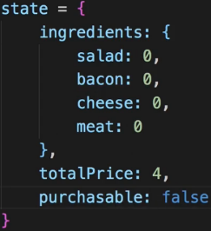

* We also use .reduce(), this time not to flatten the array but to turn it into a single number.  
=> In that function we get the new sum and the individual element. And keep in mind sum simply is the constantly updated current sum up until the current iteration where this function’s executed and once this function was executed on all array elements, sum is the final result. Element is a number because it’s the value we accessed in ingredients[igKey].  
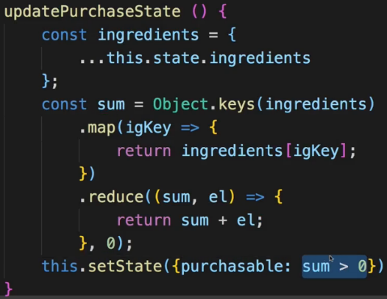  
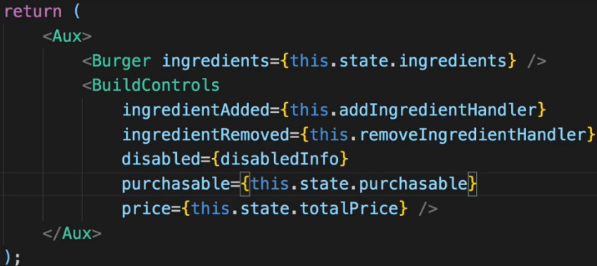  
* In BuildControls.js:  
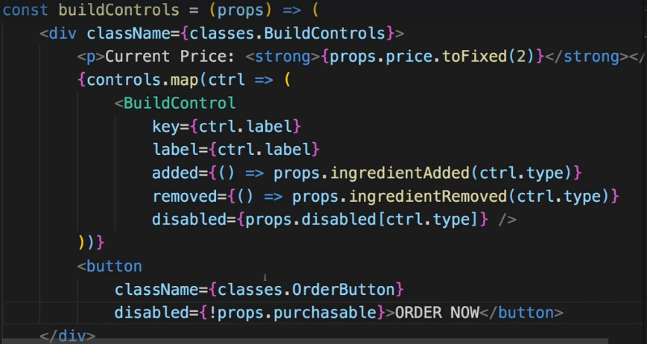  
=> **We should run the updatePurchaseState after addIngredientHandler and removeIngredientHandler**.  
=> **Add it to the end of those methods**.  
* Now if there’s 1 ingredient, it stays disabled, if there are 2, it’s enabled.   
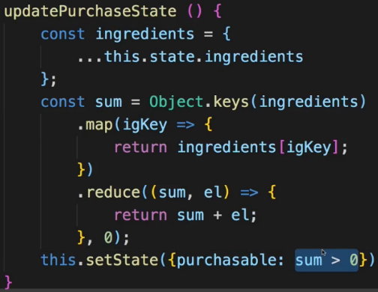  
=> The problem is that the ingredients which I’m analyzing is of course my old state here.  
=> Now due to the way setState() works, when we execute updatePurchaseState(), we might not get the updated ingredients and therefore once we copy the ingredients and analyze them, we might simply get an outdated version. Now we can of course fix it by passing the updatedIngredients to it.  
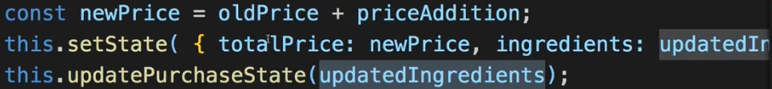  
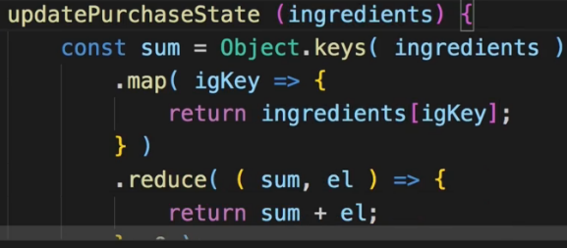  
=> Now we use that instead of the copy from the state.  
**Creating the Order Summary Modal**  
* Now once we click the button we want to open a modal with the order summary.  
* Now for that we obviously need the modal, we need a backdrop and we need to show some order summary.  
* The idea behind the modal is to have a wrapping element which provides the styling which then simply wraps itself around any content we wanna show in that modal. That makes sense to me at least.  
* I’m not adding the Backdrop to the Modal folder because we might reuse the Backdrop in other places too - for example for the SideDrawer for the navigation.  
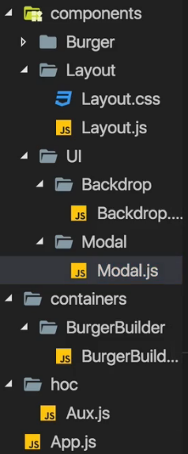 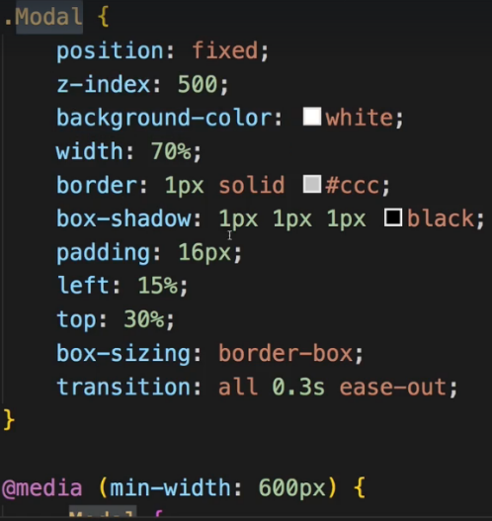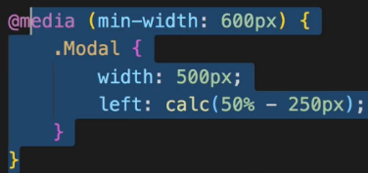  
* The {props.children} really can be anything. Our own components, some text, a paragraph,…  
=> Use the styling in Modal.css that is attached to this video.  
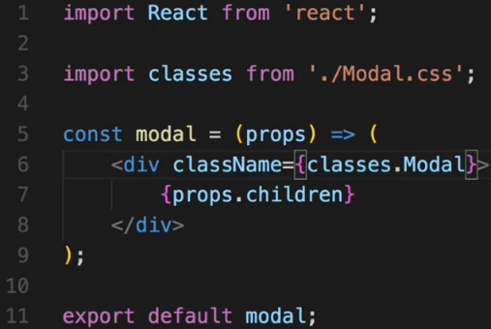  
* The question is - where in the application should we add the modal? Well, I would say we add it in a place we wanna show it because that is the logical place where it belongs and where we probably have the state and the methods to control the display. So in our case that’s the BurgerBuilder.js.  
=> The goal was to show the order summary. And this BurgerBuilder.js file is already getting quite crowded, so I don’t wanna add the logic to transform this ingredients array into a nicely structured summary into this file. I will outsource it into its own component as this is generally a good practice in React - have granular focused components.  
* It makes sense to add this on the same level as BuildControls and BurgerIngredients I guess.   
* I don’t really need a wrapping DIV here so I’ll import my **Aux** --- or use **FRAGMENTS <> </>**.  
* In the <ul> I could hard-code it but I want to create this dynamically because we’re always dynamic in React.  
* The ingredients are again in the object format and not an array. Now of course we could also create this component in a way to expect an array and transform the array in the BurgerBuilder where we will then pass it on toward the summary. But you can also do it the other way around and simply pass the object on and do the transformation in orderSummary - it’s the approach I’ll follow because I believe that this allows us to keep the burger folder a bit leaner though you could argue for both directions where this should happen.  
* Now when hard-coding this it would of course be easier because I could just hard-code 4 list items and access the respective property on the ingredients object but I want to create it a bit more flexible way.  
* We use <span> to have the ingredients with a capital letter. We use inline styling.  
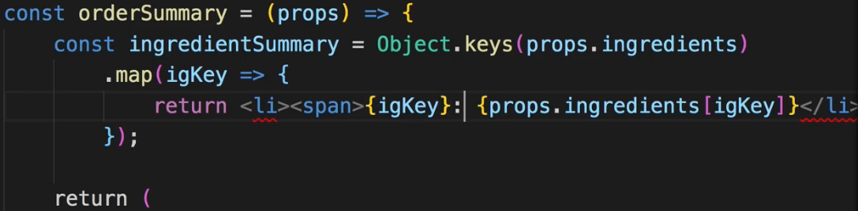  
  
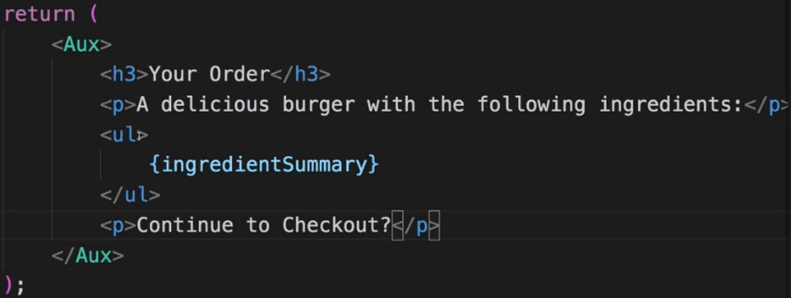  
* I won’t style this <ul> because here for this rare occasion I’ll actually use the default style of all these elements. Which is why the OrderSummary.js component doesn’t even have its own OrderSummary.css file. Though of course you are free to add one and style it.  
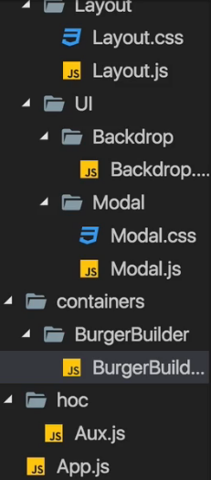

* Now in BurgerBuilder.js:  
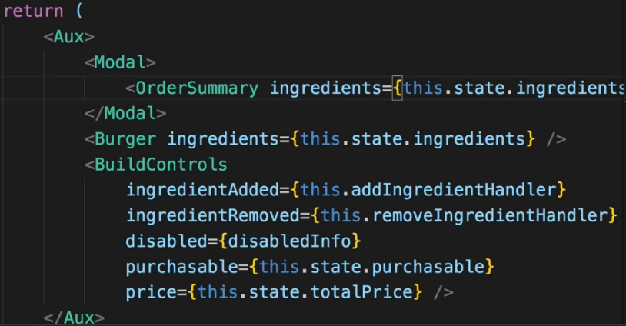  
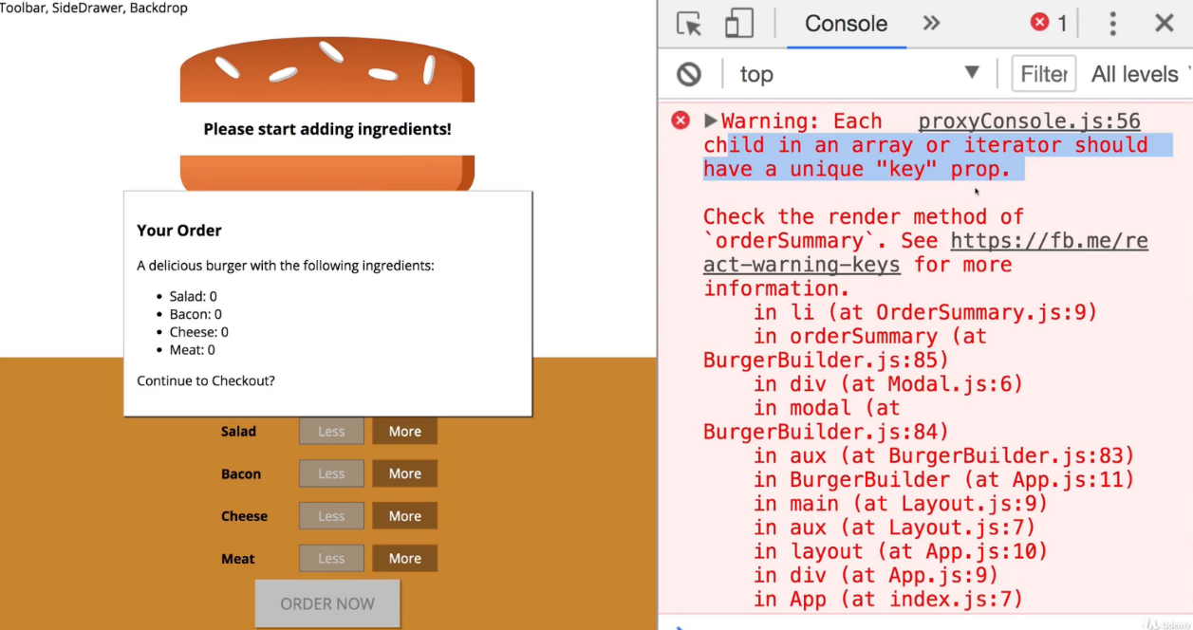  
=> We forgot to add the key to our array but generally this looks good.  
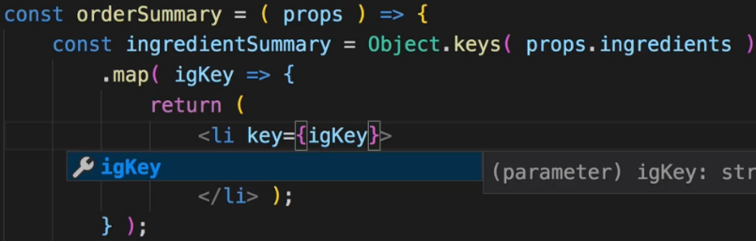  
**Showing & Hiding the Modal (with Animation!)**  
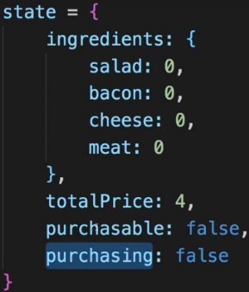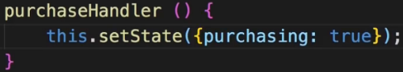  
* In BuildControls.js:  
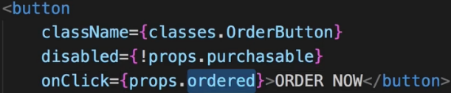  
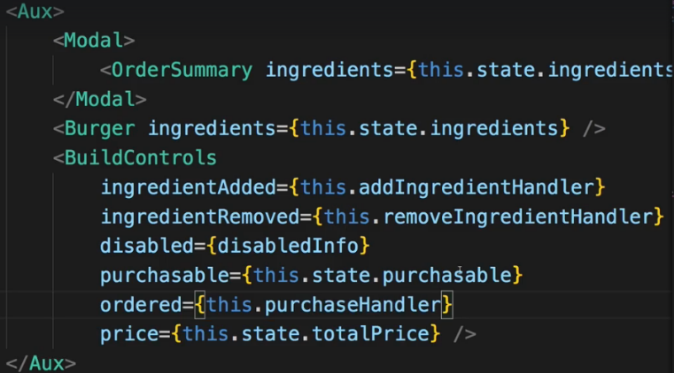  
* Now we could add some code to conditionally show or hide the Modal, this would certainly be a way.  
* Would be even nicer if we could play a tiny animation on the modal.  
* We already prepared for it in the CSS file:  
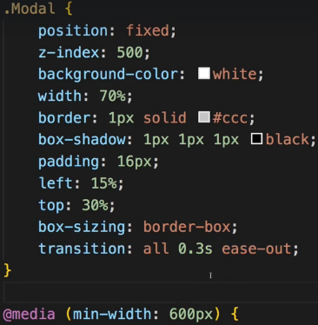  
* If we just add/remove the modal from/to the DOM, we won’t see the animation, we need to switch some CSS property to show or hide it, to be able to animate that.  
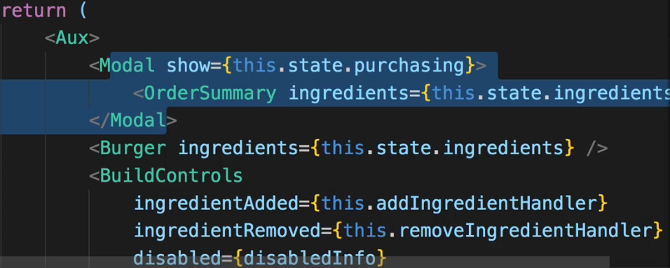  
* Now we wanna change some inline style, though you could also add a new CSS class and add this class conditionally as we do it in other places of this application already, but to also practice some inline styles, let’s use that.  
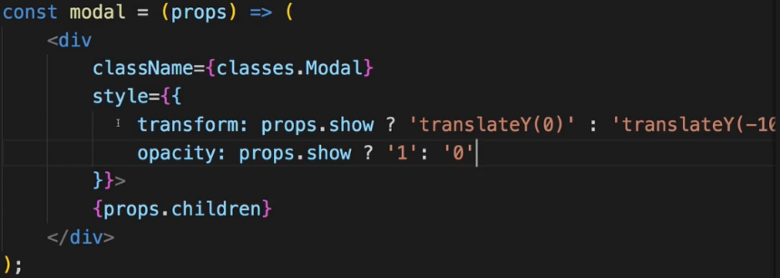  
* **Now this.setState() fails and throws an error - why?**  
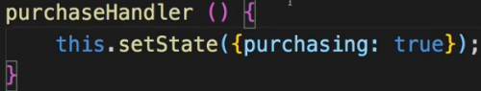=> It fails because of the way I’m creating this method. I use the same syntax as I use for render(). But earlier in the course I mentioned that that this syntax will not work correctly --- at least if we try to use the `this` keyword in there, if the method is triggered through an event. Due to the way `this` keyword works in JavaScript it will then not refer to the class. In the add/remove methods I use the ES6 arrow functions. In the end these are still methods but internally they take advantage of arrow functions which basically contain the state or the context of `this`.  
=> So we can easily fix it by using an arrow function:  
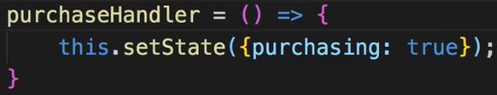  
* Now it would be good if we also had a Backdrop and if we clicked that Backdrop, it would then dismiss the modal.  
**Implementing the Backdrop Component**  
* You can return `**null**` in components.  
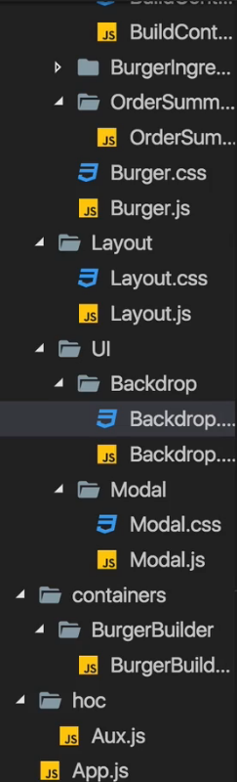 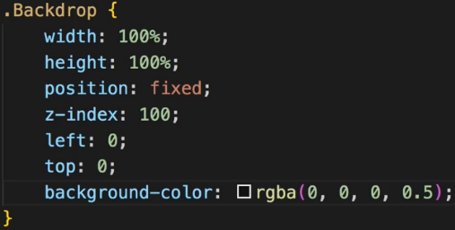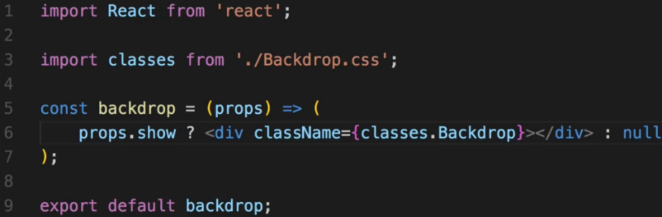  
* The .Modal has a z-index: 500, that’s important. We use z-index: 100 in the Backdrop.  
* The question is where do we add this Backdrop. Now there are multiple places where you could argue that it makes sense.  
=> One such place would be in the App.js component. Have it sit next to the Layout - outside of the Layout because it’s not part of the core page content.  
=> OR have it sit in the Layout.js component because it is part of the page but it should not be part of the main content and not be part of the toolbar or anything like that. You can definitely do that, you just need to make sure that you can then reach that by passing the -show the backdrop state- up to that component and so on. You might need to switch some Stateless components to Stateful components because maybe all of a sudden you need to define some method in a component.  
=> **I will go for another approach though - I will add the Backdrop to my Modal**.  
=> Because in my opinion, this Backdrop is closely connected to the Modal - if the Modal is shown, the Backdrop should be shown.

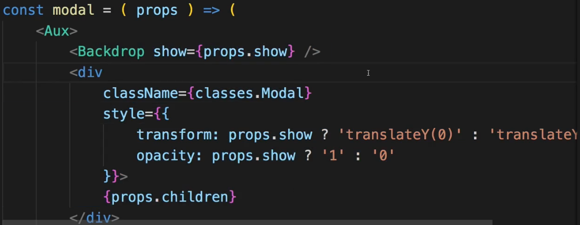  
* Let’s now make sure we can click this Backdrop too. For that we need to add a click listener inside the Backdrop on the DIV.  
  
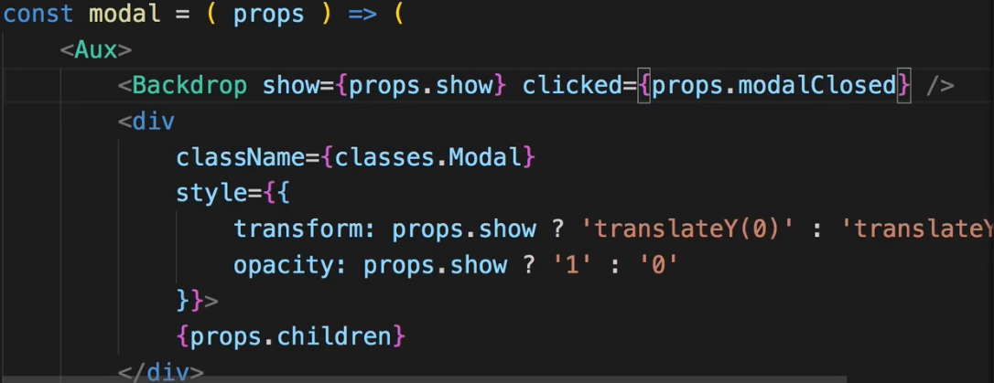  
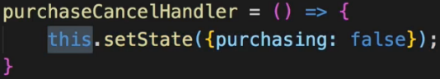 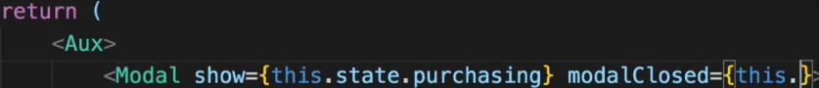  
**Adding a Custom Button Component**  
* We get a CANCEL and CONTINUE buttons in OrderSummary.js.  
* CANCEL will essentially do the same as clicking on the Backdrop does.  
* And actually I might reuse certain button styles throughout the application.  
* Having a CANCEL and CONTINUE button makes a lot of sense so maybe we should outsource the button into its own component even though there already is a button element in HTML, we might still put it into its own component so that we can wrap it with some default styling don’t have to style the button in any component where we use it, from scratch again.  
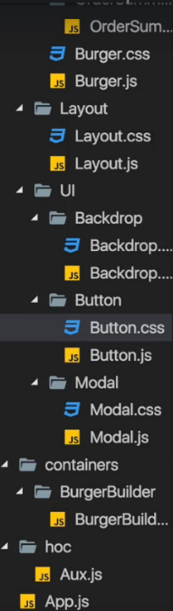  
* Again we attach a CSS file.